# User’s Guide

October 2020

# LabVIEW Oscilloscope

# Supreme Super Edition 1000 Series

[][

# Features at A Glance

|  |  |
| --- | --- |
| **Input Capabilities:**   * Wav file * CSV file   **Time Domain:**   * 4K[1] digital scope display * Double precision sampling adjustment from 10 S/s up to 1KS/s * Amplitude/div and amplitude gain adjustment * Vertical and horizontal offset adjustment * Peak to peak, RMS, and signal frequency measurements * Hold/run button * Zoom   **Frequency Domain:**   * Fast-Fourier Transform capability of whole input waveform as a separate tab * 5 toggleable dynamic Butterworth filters at 1Mhz sample rate with low cut off, high cutoff, and order adjustment between 1-20 kHz   + Low pass   + High pass   + Band pass   + Band stop   + Smoothing * toggleable moving average filters with 3 different window size to select: 4, 8, 16 | **User Interface:**   * Modern and beautiful design * Hold / run button * Save image * Reset button to switch between csv or wav input * Auto button to auto set Y-axis scale * Led indicators because they are fun when they light up * Simple design with the user in mind   **Software:**   * Program built with LabVIEW 2020 Community Edition   **CPU Usage & Memory Usage:**   * Max CPU usage observed: 9.3% * Max Memory usage observed: 104MB   **Application:**   * DC / AC measurements * Frequency analysis * Probing |

**8**

## Front Panel

**7**

**9**

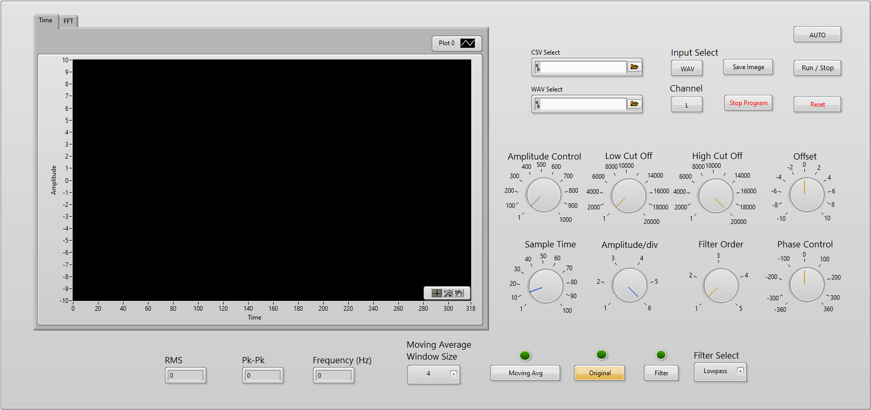

**2**

**1**

**3**

**4**

**6**

**5**

**Legend:**

1. 4K Scope Display
2. Dial Control
3. Time Domain Display for RMS, PK-PK, Frequency
4. Moving average window size select and enable
5. Original waveform or modified waveform enable button
6. Filter select and filter enable
7. Input Signal select, either CSV or WAV file input
8. Buttons: AUTO, Save Image, Stop Program, Reset
9. Tab control for Time or FFT waveform display

## First boot up

* Select CSV or Wav using buttons shown below:

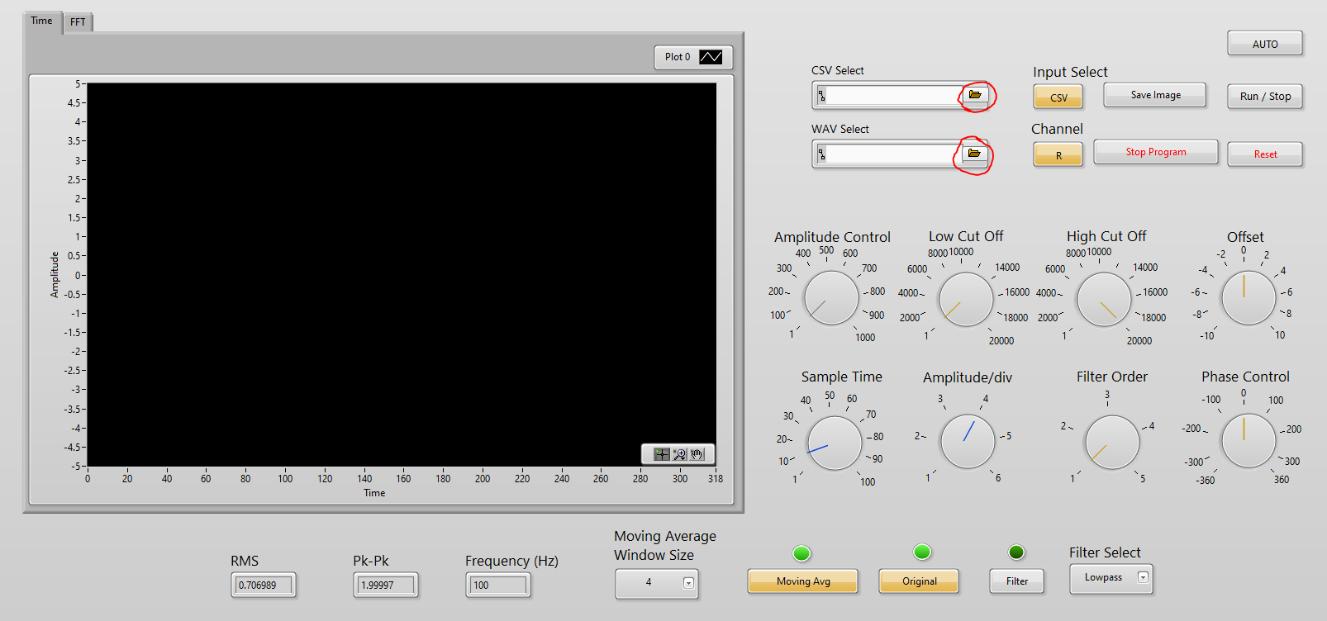

* If you do not specify a CSV and/or a WAV file, the following error could occur: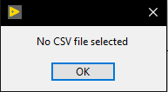 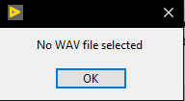
* Press OK, and stop the program with the  button
* Select CSV or WAV and rerun the program

**Note: The Oscilloscope will still be able to function properly even only one of the inputs (CSV or WAV) are specified. You will just not see anything for the unselected file.**

## Time or FFT Display

* The ***Time*** tab will display the input signal point by point with a sampling time defined using the ***Sampling Time*** dial
* Select the ***FFT*** tab if you want to view your input waveform in the frequency domain

## Filtering

* Unselect the original waveform by pressing the ***Original*** button. Note the green LED will turn off for the ***Original*** button.
* Press the ***Filter*** button, the ***Filter*** green LED should turn on.
* Select the required filter with the ***Filter Select***  drop down

## Original Waveform

* Keeping the ***Original*** button ON (Orange), the user will not be able to see differences when adjusting the any of the dials except for the amplitude/div dial

## Switch from CSV to Wav mid operation

* Press the ***Input Select*** button
* Press ***Reset*** button

## Moving Average

* Simply select the moving average window size using the provided drop down
* To enable the moving average function, press the ***Moving Avg*** button

1. This is the dream